A picture containing clipart

Description generated with very high confidence

Azure 103 Module 4

Hands On – 8

Azure Certification Training

[**support@intellipaat.com**](mailto:support@intellipaat.com)

**+91-7022374614**

**US: 1-800-216-8930(Toll Free)**

**Azure 103 Module 2 , Hands On – 8**

**Use Storage Queues.**

**Step 1:** Open Storage Account.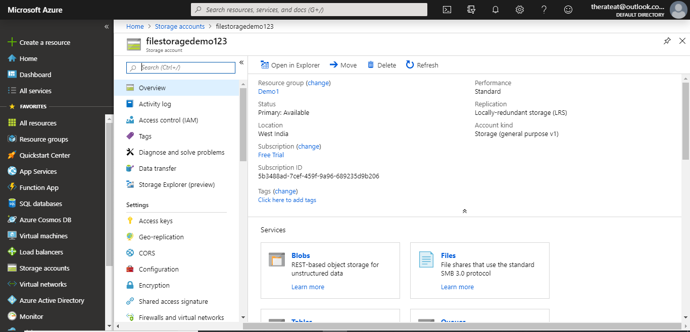

**Step 2:** In the Settings section click on Access Keys.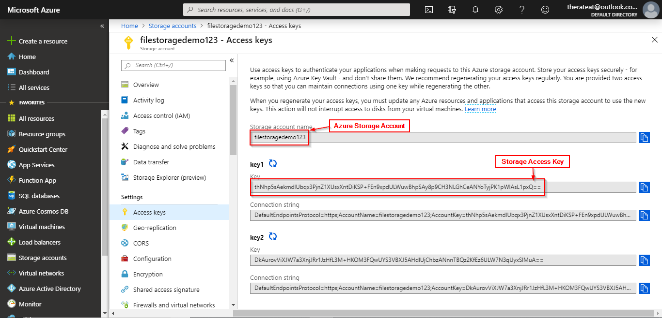

**Step 3:** Open config.js file in the sample app.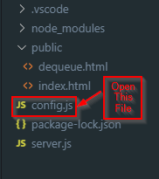

**Step 4:** Replace queueName to the name of your queue (if you have not created a queue then it will be created automatically for you), azureStorageAccount value to your storage account name and azureStorageAccessKey to the access key of your storage account.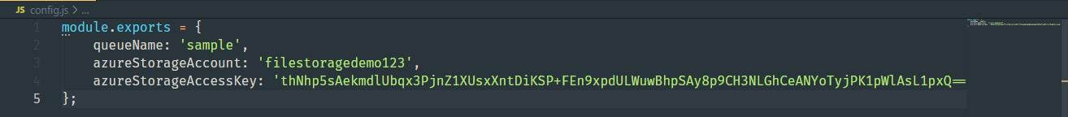

**Step 5:** Open Command Prompt or Terminal and navigate to the folder with sample code.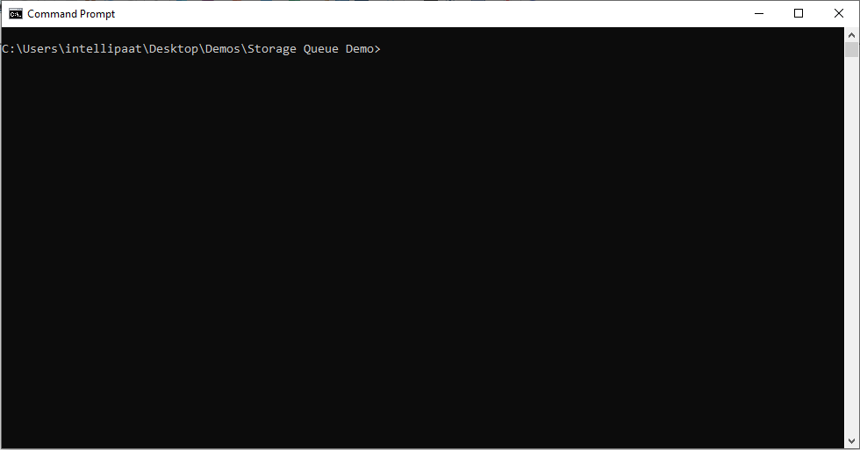

**Step 6:** Enter the following command: 'node server.js', start our application server.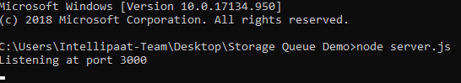

**Step 7:** In your browser go to <http://localhost:3000>.

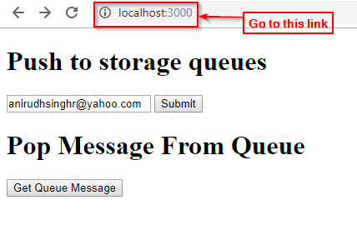

**Step 8:** In the app enter data in the text field and press submit to enter data in the queue.

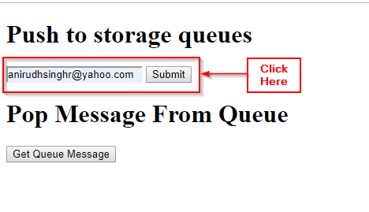

**Step 9:** Open the Storage Queue in Azure Portal.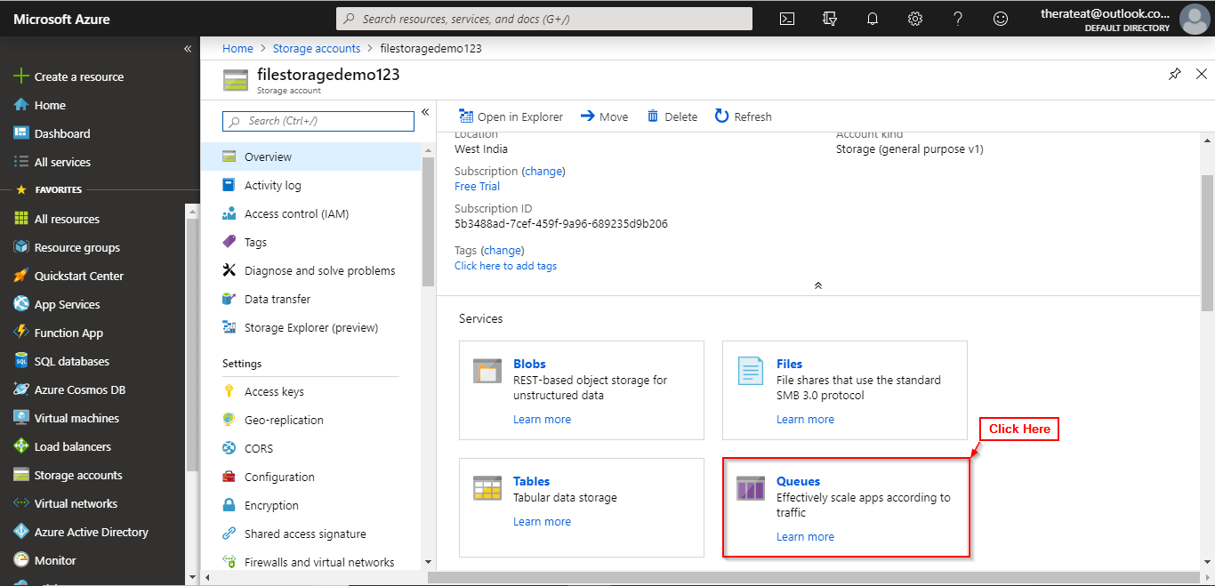

**Step 10:** Click on the queue you created.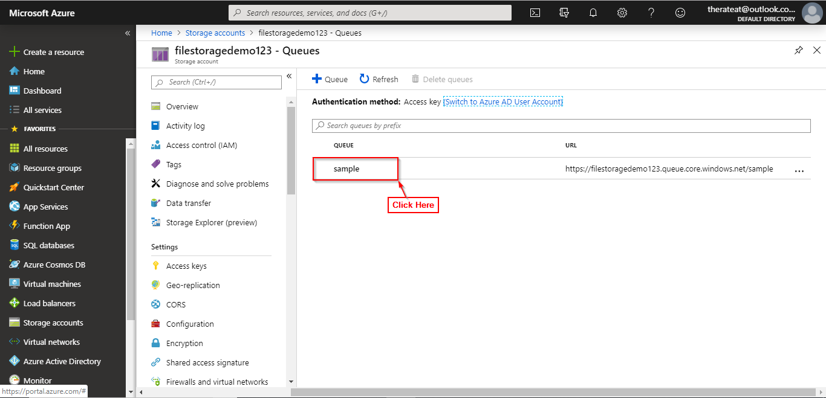

**Step 11:** Observe that your messages have been added to the queue.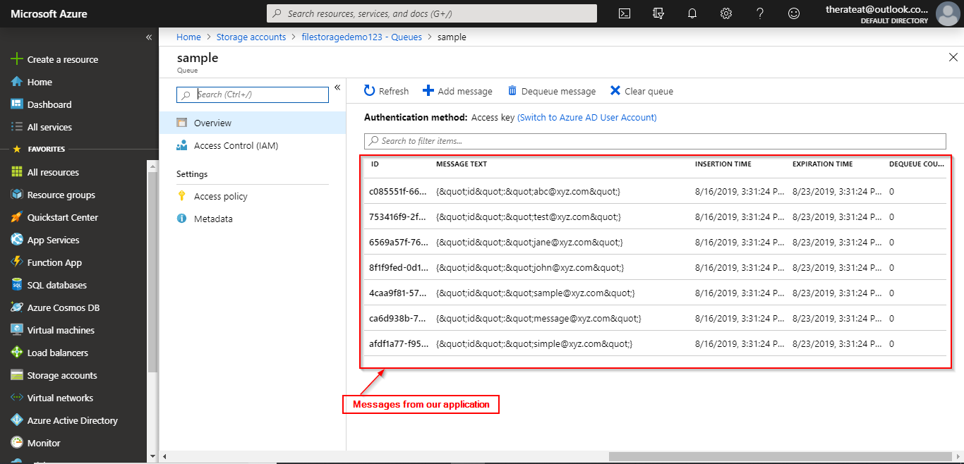

**Step 12:** Open <http://localhost:3000> and click on ‘Get Queue Message’. An alert box will show up showing the message and if the queue is already empty.

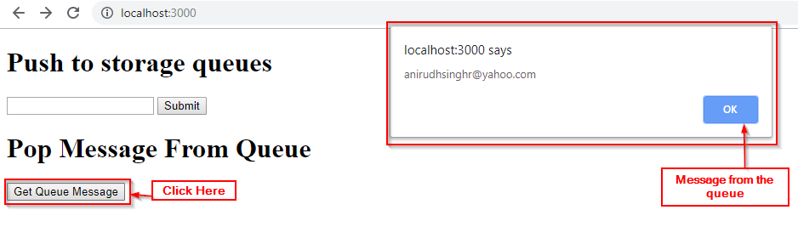

**Step 13:** Open the queues page and refresh it. You will notice that all the previously added message are now gone.